# DIGITAL SKILLING IMPACT

Between July 2022 and June 2024 a diverse range of training initiatives were delivered by the Digital Professional Workforce Action Plan (DPWP), successfully reaching 64 of the 78 local government areas across Queensland.

With a goal of training 10,000 individuals in digital skills by 30 June 2024, DPWP well exceeded this, training 15,787 Queenslanders.

Outside of South East Queensland, there was participation from the most remote areas of Queensland. Over 2,200 Queenslanders in North Queensland upskilled in digital including First Nations communities such as Palm Island and the mining town Mount Isa.

In the Far North Queensland, 1,639 Queenslanders enhanced their digital skills from the Torres Strait and Yarrabah.

Spread of training across Queensland

Central Queensland saw participation from 1,158 Queenslanders, in places like Isaac, Livingstone and First Nations Queenslanders living in Woorabinda and the Wide Bay Burnett region with 103 participants.

The Darling Downs South West also engaged in learning from as far west as Quilpie and Murweh to the south in Goondiwindi. A total of 925 individuals from the region took up the opportunity to get involved in training programs.

Demographic data[1] of training participants was as follows:

15,787 Queenslanders participated in digital skills training.

82%

6,502 were women.



9,414 were from regional Queensland.

of local government areas received digital skills training.

3,973 First Nations Queenslanders received training.

739 were culturally and linguistically diverse.

2,747 were from a business or community organisation.

186 identified as neurodiverse.

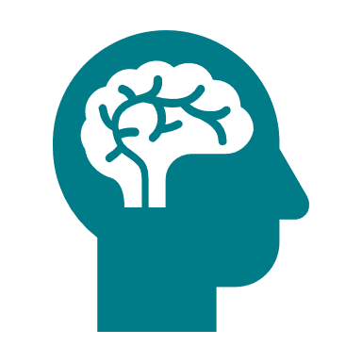

1. Australias_Digital_Pulse_2023_Digital.pdf